Pray Anson

April 1 – 30, 2023

We love our home! We love beautiful Anson County! We love the people that live and work here! And we are called of God to pray for our friends, neighbors co-workers and family! Will you join us in praying for the spiritual and physical needs of this county and its people that we love so much? These are tough days and the people of Anson County need God’s blessings and our prayers more than ever! The Bible says, “I exhort therefore, that, first of all, supplications, prayers, intercessions, and giving of thanks, be made for all men” (1 Timothy 2:1).

It is estimated that over half of the population of our county of 22,055 people are not a member of anyone’s church and therefore, most likely, lost and headed to hell because of their unwillingness to trust and accept the salvation that Christ offers through His death and resurrection.

That should break our hearts! But what can we do? Pray! We should pray with the confidence that God does not want any one of them to go to hell! The Bible says, “The Lord … is longsuffering to us-ward, not willing that any should perish, but that all should come to repentance” (2 Peter 3:9). God in His love sent Jesus to be the Savior of the world! Let us be faithful to pray for the salvation of those that we love and who live with us Anson County! The guide below gives you some people and needs that you can pray for each day. Let’s cover our county in the month of April in prayer!

Thank you for praying for the physical and spiritual needs of our friends and neighbors in Anson County!

[P]raying always with all prayer and supplication in the Spirit, being watchful to this end
with all perseverance and supplication for all the saints…. (Ephesians 6:18)

Abbreviations: (ABA) Anson Baptist Association; (AC) Anson County;
1 Ansonville Baptist Church  Pastor: Rev. Jeff Glenn  Lost family members  Town of Ansonville  ACC, JD Bricken (chair)  Lilesville Fire Dept. | 2 Brown Creek B. Church  Pastor: Rev. Johnny Williams  Lost extended family  Town of Lilesville  ACC Robert Mims (Vchair)  Peachland Fire Dept. | 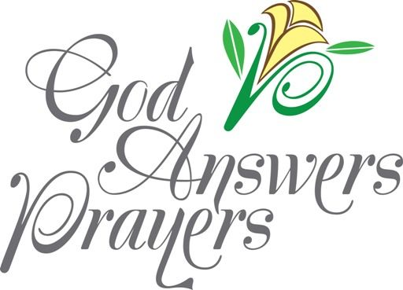 | Abbreviations  (AC) Anson County  (ABA) Anson  Baptist Association  (ACC) Anson County Commissioners
(ACC) Anson County Commissioners; (ASB) Anson County School Board; (SS) Anson County Social Services
3 Calvary Baptist Church  Pastor: Rev. Barry Gerald  Lost friends  Town of Peachland  ACC, Jarvis Woodburn  County Manager: Leonard Sossamon | 4 Cathedral Bapt. Church  Pastor: Rev. Randy Swaringen  Lost neighbors  Town of Polkton  ACC, Priscilla Little | 5 Cedar Grove Bapt. Church  Pastor: Rev. Mark Swaringen  Lost co-workers  Town of McFarlan  ACC Jamie Caudle  Rodney Diggs, Emergency Management | 6 Deep Creek Bapt. Church  Pastor: Rev. Mark Perko  Lost among the African American population  Town of Morven  ACC, Lawrence Gatewood  Sheriff: Scott Howell
7 Deep Springs B. Church  Pastor: Rev. Henry Haney  Lost among the  Hispanic population  Town of Wadesboro  ACC, Harold C. Smith | 8 Faith Baptist Church  Pastor: Rev. Rick Eason  Those who never attend church  Church Leaders  Ansonville Fire Dept.  County & Town Police forces | 9 Fall Branch Bapt. Church  Pastor: Rev. Joe Blocker  Those who seldom attend church  Anson Baptist Association  Gulledge Fire Dept.  ACC Clerk, Denise Cannon | 10 Freedom Bapt. Church  Pastor: Rev. Bill High  Those who are “backslidden”  ABA, Rev. David Ross, AMS  Lanesboro, Fire Dept.
[I]f My people who are called by My name will humble themselves, and pray and seek My face, and turn from their wicked ways, then I will hear from heaven, and will forgive their sin and heal their land” (2 Chronicles 7:14).

11 Gum Springs B. Church  Pastor: Rev. Tom Walden  Anson Early College  ABA, Mrs. Kim Glenn  Wadesboro Fire Dept. | 12 Lilesville Bapt. Church  Pastor: Rev. Teddy Lawson  Anson High School  ABA, Mark Perko  Racial unrest | 13 Mineral Springs B. C.  Pastor: Rev. Marty Quick  Anson Middle School  ABA, Randy Storz  School teachers | 14 Morven Bapt. Church  Pastor: Rev. Tommy Threatt  Ansonville Elementary School  ABA, James Parks  Atrium Health Hospt. Anson
15 Mount Beulah B. C.  Pastor: Rev. Randy Storz  Lilesville Elementary  ABA, Jennifer Tarlton  Meadowview Terrace of Wadesboro | 16 Mount Carmel B. C.  Pastor: Rev. Tim Helms  Morven Elementary  ABA, Lynn Whitlock  Anson Health & Rehabilitation  Drug & Alcohol Abuse | 17 Mount Zion B. Church  Pastor: Rev. James Hodges  Peachland-Polkton Elementary  ABA, Larry Kendall  Lillie Bennett Nursing Center  Those with mental health issues

“Brethren, my heart's desire and prayer to God for Israel is that they may be saved.” (Romans 10:1)

18 New Home B. Church  Pastor: Rev. Scott Baucom  Wadesboro Primary School  ABA, Jerome Cash  Ambassador Rehabilitation and Healthcare Center | 19 North Wadesboro B. C.  Pastor: Rev. Donnie Helms  Wadesboro Elementary S.  ABA, Ann Thomas  ASB, Carol Ann Gibson  Gangs & Violence | 20 Oakdale Baptist Church  Pastor: Rev. Tracy Hickson  School Superintendent:  ABA, Churches w/o Pastors  ASB, School Superintendent:  Dr. Howard E. McLean  ASB, Bobbie Little Vice | 21 Peachland Bapt. Church  Pastor: Rev. Jerome Cash  ABA, Henry Haney  ASB, Marilynn Bennet  Families living in poverty  Single Parent Families
22 Pleasant Grove B. C.  Rev. Kevin Ricketts (supply)  County Employees  ABA, Henry Haney  ASB, Lisa Davis | 23 Polkton Baptist Church  Pastor: Rev. John Greene  School Social Workers  ABA, Nancy Gulledge  ASB, George Truman - Chair | 24 Red Hill Baptist Church  Pastor: Rev. Rodney Clements  Other School Staff  ASB, Marilynn Bennett | Abbreviations  (ASB) Anson County  School Board  (SS) Anson County  Social Services  (ABA) Anson  Baptist Association

“Now this is the confidence that we have in Him, that if we ask anything according to His will, He hears us. And if we know that He hears us, whatever we ask, we know that we have the petitions that we have asked of Him.” (1 John 5:14-15)

25 Rocky Mount Baptist C.  Int. Pastor: Rev. Ozzie Vater  Karen Baucom  Anson County Domestic Violence Coalition | 26 Rocky River B. Church  Pastor: Rev. Dennis Stegall  Anson Crisis Ministry  ASB, Frank Liles Vice chair  Social Services (SS) | 27 Southside Baptist C.  Pastor: Rev. Cliff McKnight  Burnsville Learning Center  ASB, Judy Little  SS, Lula Jackson, Dir | 28 Victory Bapt. Church  Pastor: Rev. Frank Mims  Feed My Lambs Ministry  ASB, Beulah Pratt  SS, Kishia Dunlap
29  ASB, Mike Turner  SS, Mary Kendall  Hope Pregnancy Center  County Unemployment  County Crime | 30 Pray for LOVE  ANSON DAY!  SS, Monique Freeney  Samaritan’s Inn Homeless Shelter, Rev. M. Chambers  AC Health Department | Love  Anson Day

A ministry of Anson Baptist Association. Find out more on the web at:
www.ansonbaptist.org, email: ansonbaptist@yahoo.com or by phone at (704) 694-2790
Pray Anson Prayer Guide
April 2023

“Again I say to you that if two of you agree on earth concerning anything that they ask, it will be done for them by My Father in heaven. For where two or three are gathered together in My name, I am there in the midst of them.” (Matthew 18:19-20)

This prayer guide is designed to be used each week during the month of April as an aid in praying for our county. Please use it in any way that will help you to pray for the spiritual and physical needs of our county. Share a copy with a friend! Additional copies can be found on the Anson Association Website: www.ansonbaptist.org.

Week 1:
Lost and Unchurched. “Brethren, my heart's desire and prayer to God for Israel is that they may be saved.” saved. (Romans 10:1)

According to a recent Gallup Poll, 53% of Americans are not a member of anyone’s church. While the issue of salvation is much larger than church membership (especially when you consider other religions and cults), let’s use that as an indicator to give us a glimpse into the spiritual need and lostness of the residents of our county. The 2020 census estimates the population of Anson County to be 22,055. 53% of that number would be 11,689. Assuming that those who are not a member of a church are not Christians, then over half of our population, 11,689 are lost and headed to hell because of their lack of faith in Jesus as their Savior and Lord.

Who are these people? They are our families, friends, neighbors and co-workers. We grew up and went to school with them. We know many of them personally by name and care very deeply for them. Will you spend time this week praying for their salvation? Will you pray for those who have wondered from the faith to come back to Jesus? Will you ask God to help you to have the courage to invite them to church, to share with them how and why you became a Christian. Will you share the plan of salvation with them using the Bible, a tract or a web-based resource?

There are an estimated 65 – 80 churches in Anson County. Statistics tell us that 9 out of 10 churches in America are plateaued or declining. Will you pray for the churches in our county to preach the Bible, to proclaim the good news of the gospel, to love the lost more than they love themselves and to die to their preferences so that they might better reach the lost who are all around them?

Week 2:
A. Schools. [P]raying always with all prayer and supplication in the Spirit, being watchful to this end with all perseverance and supplication for all the saints— (Ephesians 6:18)
- Pray for our schools & their principles: Ansonville Elementary, Michael Vetter; Lilesville Elementary, Becky Flake; Morven Elementary, Dionnya Pratt; Peachland-Polkton Elementary; Travis Steagall; Wadesboro Elementary, Daniel Burrows; Wadesboro Primary, Arthur Jackson; Anson Middle School, Darrell Potts; Anson Early College, Carri Decker; Anson High, Chris Stinson
- Pray for our teachers and staff
- Pray for our students
- Pray for our leaders in the central office. Superintendent: Howard McLean
- School Board: George Truman (Chair), Frank Liles (Vice Chair), Carol Ann Gibson, Mike Turner, Beulah Pratt, Bobbie Little, Lisa Davis, Marilynn Bennett and Judy Little
- South Piedmont Community College staff and students

B. First responders. “…[T]hrough love serve one another.” (Galatians 5:13)
- Anson County Sheriff Scott Howell & Deputies
- Town police
- Fire Departments
- Rescue Squads
- Anson County Emergency Management

Week 3:
A. County Leaders. “… I exhort first of all that supplications, prayers, intercessions, and giving of thanks be made for all men, for kings and all who are in authority, that we may lead a quiet and peaceable life in all godliness and reverence. (1 Timothy 2:1-2).

- Anson County Board of Directors: JD Bricken (chair), Robert Mims (vice Chairman), Jarvis T. Woodburn Lawrence Gatewood, Harold C. Smith, Jamie Caudle, Priscilla Little.
- County Department leaders and workers
- Town leaders and workers

B. Business & Jobs. “But seek first the kingdom of God and His righteousness, and all these things shall be added to you.” (Matthew 6:33)

These are trying time for most people, and many businesses are struggling too. Covid and soaring prices have taken a toll on our local businesses too. There are an estimated 388 businesses in our county with a pay roll of some 165 million dollars.
- Pray for our business owners, small and large.
- Pray for a stable economy and business environment so that businesses and their employees can prosper.
- Pray for wisdom for our county leaders to be able to attract more businesses and jobs to our county.
- Pray for the salvation of business leaders and their workers
- Pray that businesses will take good care of their employees.

Week 4:
A. Crime. “But I say to you, love your enemies, bless those who curse you, do good to those who hate you, and pray for those who spitefully use you and persecute you. (Matt 5:44)

According to crimegrade.org, “The rate of crime in Anson County is 54.76 per 1,000 residents during a standard year.” “Anson County is in the 16th percentile for safety, meaning 84% of counties are safer and 16% of counties are more dangerous.”
- Pray for the souls of those who commit crimes
- Pray that those who are addicted to drugs or alcohol would be saved and set free from their addictions.
- Pray that we can find ways to redeem those who are guilty of crime for Christ.
- Pray for the victims of crime

B. Social needs. But seek the welfare of the city where I have sent you into exile, and pray to the LORD on its behalf, for in its welfare you will find your welfare. (Jeremiah 29:7)

The further our nation moves away from God, the greater the social needs grow among us. Rebellion and disobedience to God brings more sin and suffering.
- Poverty. The 2020 census found that 21.4% of Anson County lives in poverty. That means that 1 out of 5 people in our county live in poverty. Pray for God’s provision for the poor and for them to receive the right kind of help that will lift them out of poverty.
- Pray about the needs of: mental health, broken families, divorce, domestic violence, single parent families, affordable housing, drug abuse, human trafficking
- Pray for the Christian service organizations that minister to the needy in our county: Anson Crisis, Feed My Lambs, Burnsville Learning Center, Anson County Domestic Violence Coalition
- Pray for secular service organizations: Anson County Social Services, Anson County Health Department, Sandhill’s Community Action Program

C. Pray for Love Anson, April 29th!
- Pray for our churches to have a burden to reach and serve their communities with God’s Love.
- Pray that they will use Love Anson to serve their community and not their own membership
- Pray for vision and creativity in the ways that they choose to reach out, serve and witness.
- Pray that some will be saved during this special time of ministry and service
- Pray that God will be glorified in everything that is done!

Prayer Walking Your Community

Jesus traveled from town to town engaged in teaching the Word of God and ministering compassionately to those who had needs (Mark 9:35-36). The Bible commands us to pray for all people. “Therefore I exhort first of all that supplications, prayers, intercessions, and giving of thanks be made for all men” (1 Tim. 2:1).

Prayer walking is one way to follow the example of Jesus and the commands of scripture. It is walking through your community with your eyes wide open to see how God would lead you to pray for your neighbors. Real prayer is not praying for what you want for your neighbors, but God’s perfect and compassionate will for them. Praying while walking through the neighborhood is praying for God’s blessings and will for each house and family. It is seeking God’s provision for their spiritual and physical needs.

As you walk, you may see a neighbor’s house whom you know is going through a hard time, and so you pray for their need. Another neighbor may be struggling with a rebellious teen. You might see another house and wonder who lives there. You might see children’s toys in the yard and feel led to pray for the salvation of the children or for strength and wisdom for the parents as they cope with the normal stresses of working and raising a family in today’s society. Prayer walking is allowing the Holy Spirit to guide your prayers as you see different homes, people, businesses or needs. It is lifting up your neighbors to Christ and asking Him to work in their families and lives for His glory. Prayer walking is simply praying for your neighbors.

Preparing to Prayer Walk.

- Are the houses in your community close together or far apart? Is walking preferable or riding in an automobile? With concerns about Covid-19, walking outside and staying physically distanced works well, but you may choose to ask only families or close friends to ride together to cover their area in prayer in a more rural area.
- Divide your community up into streets or sections for each group to prayer walk or ride. You don’t want everyone going to the same place.
- Pick a date. Our association is encouraging churches to prayer walk their communities on April 17th.
- Plan to meet at the church on the day of your prayer walk for prayer, brief instructions and a prayer before the teams are sent out (30 minutes or less). Plan an hour for the Prayer Walk.
- Plan to return to the church for a brief follow up - sharing time.

Instructions for Prayer Walking:

- Prayer Walking should be done in groups of two or three.
- Young children should prayer walk with their parents.
- Highways or busy streets should not be assigned unless sidewalks are available.
- Streets being Prayer Walked should be mapped out in advance to prevent streets from being
- walked twice.
- Prayer Walkers should try not to draw attention to themselves.
- Take time to enjoy the walk and be friendly to those you meet outside.
- If you have items to put on the door handles of the homes, leave them without knocking.
- If you encounter people in their yards, explain what you are doing and ask if they have any
prayer requests of specific things you can pray for.

Instructions for Prayer Riding:

It is easier for walkers to pray as they slowly walk along together, but it can be more challenging while driving. Everyone should keep their eyes open to see what God is showing them and may be leading them to pray for (especially the driver!). Sometimes it is possible to drive slowly, other times it is not. We do not want to be a hindrance or a safety hazard to others who are driving behind us. So, look for regular places to pull over, or pull off, to pray about the homes and families that you have just seen, but preferably, not the driveways of strangers.

Praying While Walking or Driving

What should you pray for? What do you see? Do you see evidence of children? Does the person seem well off or poor? Do you know anything about the person who lives there that could inform your prayers for them? Make sure that you pray for the spiritual needs such as salvation, commitment to God, right relationship to the Father, etc. Next pray for any physical needs that you are either aware of or that God places on your heart.

Praying for Christians

- Pray for believers to be renewed in the joy of God’s salvation (Psalm 51:10-13).
- Pray for believers to live a Christ-like character before the world (John 17:11).
- Pray that Christians will experience the joy of Jesus in their lives (John 17: 13).
- Pray for divine protection from Satan (John 17:15).
- Pray that believers will live set apart and holy lives in Christ (John 17:17).
- Pray for Christians to be united in the mission and purpose of Christ (John 17: 20-21).
- Pray that believers will join Christ in His redemptive work (John 17: 24).

(Copied from “Prayer/empower Weekend Coordinator Leadership Guide, p. 9)

Praying for the Lost

- Pray for receptive hearts (Luke 8:5-15).
- Pray for their eyes and ears to be opened (Matt. 13:15; 2 Cor. 4:3-4).
- Pray for unbelievers to have and understand God’s attitude toward sin (John 16:8).
- Pray for the lost to be released from barriers and strongholds that hinder faith
(2 Tim. 2:25-26).
- Pray for unbelievers to experience a transforming life in Christ (Rom. 12:1-2).
- Pray for Christian witnesses to be sent to share Christ with the lost (Matt. 9:35-38).

(Copied from “Prayer/empower Weekend Coordinator Leadership Guide, p. 9)

A ministry of Anson Baptist Association. Find out more on the web at:
www.ansonbaptist.org, email: ansonbaptist@yahoo.com or by phone at (704) 385-8102

Pray Anson

April 1 – 30, 2023

“Therefore I exhort first of all that supplications, prayers, intercessions, and giving of thanks be made for all men” (1 Timothy 2:1).

Join our sister churches in praying for our great county during the month of April!
Prayer helps to open the doors of the power of God to make a wonderful
difference in lives of our family, friends and co-workers! Let’s pray!
Pray Anson

April 1 – 30, 2023

“Therefore I exhort first of all that supplications, prayers, intercessions, and giving of thanks be made for all men” (1 Timothy 2:1).
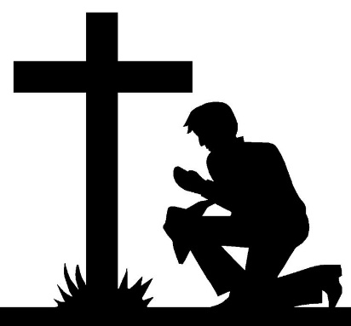

Join our sister churches in praying for our great county during the month of April!
Prayer helps to open the doors of the power of God to make a wonderful
difference in lives of our family, friends and co-workers! Let’s pray!

Pray Anson

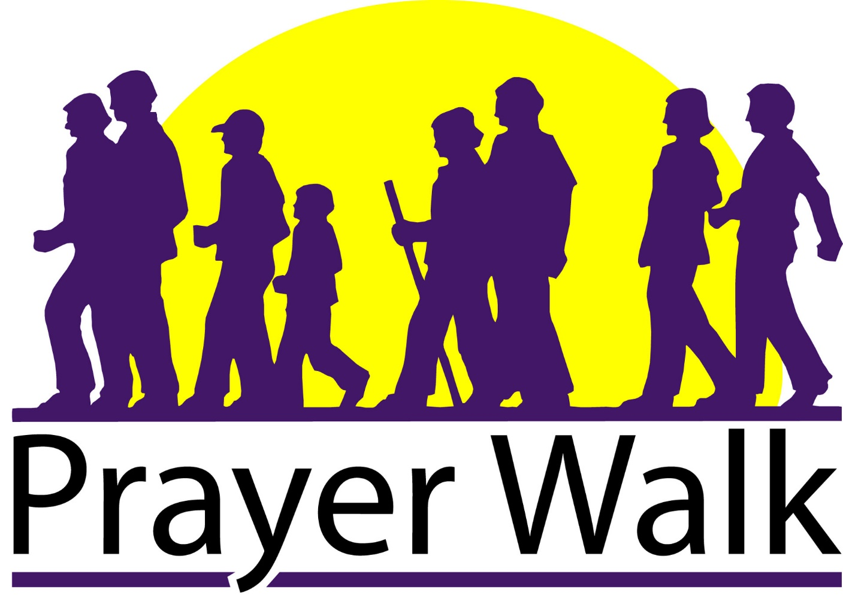

Date

Time

“Therefore I exhort first of all that supplications, prayers, intercessions, and giving of thanks be made for all men” (1 Timothy 2:1). Let’s cover Anson County in prayer!

