Pray Anson

April 1 – 30, 2023

“Therefore I exhort first of all that supplications, prayers, intercessions, and giving of thanks be made for all men” (1 Timothy 2:1).

Join our sister churches in praying for our great county during the month of April! Prayer helps to open the doors of the power of God to make a wonderful difference in lives of our family, friends and co-workers! Let’s pray!

Pray Anson

April 1 – 30, 2023

“Therefore I exhort first of all that supplications, prayers, intercessions, and giving of thanks be made for all men” (1 Timothy 2:1).

Join our sister churches in praying for our great county during the month of April! Prayer helps to open the doors of the power of God to make a wonderful difference in lives of our family, friends and co-workers! Let’s pray!

Pray Anson

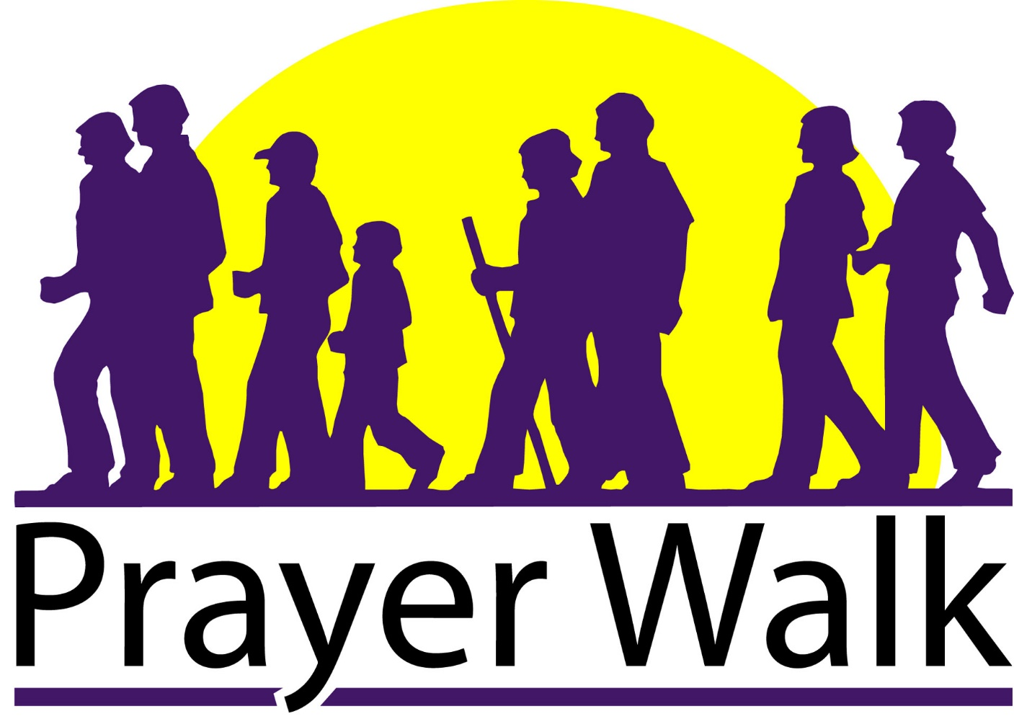

Date

Time

“Therefore I exhort first of all that supplications, prayers, intercessions, and giving of thanks be made for all men” (1 Timothy 2:1). Let’s cover Anson County in prayer!

