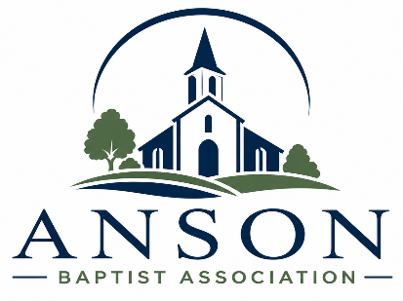
Anson Baptist Association
P. O. Box 958, 2710 US 74 W
Wadesboro, NC 28170
Phone: (704) 694-2790
Email: ansonbaptist@yahoo.com
Web: www.ansonbaptist.org
Follow us on Facebook: Anson Baptist Association on Mission
Churches

Ansonville

Brown Creek

Calvary

Cathedral

Cedar Grove

Deep Creek

Deep Springs

Faith

Fall Branch

Freedom

Gum Springs

Lilesville

Mineral Springs

Morven

Mt. Beulah

Mt. Carmal

Mt. Zion

New Home

North Wadesboro

Oakdale

Peachland

Pleasant Grove

Polkton

Red Hill

Rocky Mount

Rocky River

Southside

Victory

October 2026

Follow me to the…

Anson Baptist Association
Fall Meeting

October 11, 2026

Brown Creek
Baptist Church
4210 Hwy. 742 N
Wadesboro, NC 28170

Session 1 at 4:00 p.m.
Supper at 5:15 p.m.
Session 2 at 6:30 p.m.

Key Speaker:
Rev. Greg Queen

Join us for a great time of fellowship, worship, special
music, information, food and preaching! Bring a friend!







Have you appointed your Anson Baptist Association Messengers?

While everyone is invited to attend and worship at our Fall Meeting, only those who have been appointed by your church as messengers can vote in the business sessions. So, please make sure that your church appoints messengers by whatever policy is appropriate in your church. Every church in our association is entitled to at least 3 messengers! Join us for great speakers, music, food and fellowship! It would help us if you could send your messenger names before the Meeting on Oct 11th to ansonbaptist@yahoo.com or (704) 694-2790. We are looking forward to seeing, worship, eating and Fellowshipping with you!!

October 2026 Calendar

Sun 4, Cooperative Program Day
5 – 11, Week of Prayer for the Anson Baptist Association
Sun 11, ABA Fall Meeting, 4:00 PM Session 1, Dinner,
5:15 PM, Session 2, 6:30 PM
Sat 24, Mission Trip to Red Springs Mission Center



Judy Williams – 3
Dennis Stegall - 12
Kimberly Hickson – 20
Sharon Mullis - 20
James Hodges – 23
Danielle Clements - 27
Jennifer Ricketts - 28

November 2026 Calendar

Sun 1, Daylight Savings Time Ends.
Mon. 2, World Day of Prayer
Tues. 3, Election Day. Every Christian should be “salt
& light,” a good citizen, and vote!
Sat. 7, at 5:30 p.m. ABA Pastor & Wives Banquet at
the ABA. Please make your reservations soon!
Thurs. 12, at 6:15 Baptist On Mission Men’s Worship
Rally at New Home Baptist Church.
15 – 16, NCB Pastor’s Conference, Greensboro
16 – 17, NCBSC Annual Meeting, Greensboro
16 – 23, Operation Christmas Child National Collection
Week


Anson Baptist Association

Week of Prayer

October 5 - 11, 2026

Prayer guides are available through our office, by email or on our website at: https://www.ansonbaptist.org/_files/ugd/20df5b_c14bd99e42d044e5b0f39fec422c4d31.pdf

One Day
Mission Trip to the
Red Springs Mission Center
Saturday, Oct 24th


Plan to arrive at Red Springs before 9:00 AM. We plan to leave between 2:00 – 3:00 PM. Teams should bring any water and snacks that they would like. Lunch will be provided.

Participants must be 13 years or older. Youth groups must have a 1:4 ratio of adult to youth. Teams that include youth under 18 must follow BOM Background Check policy. Please contact the ABA by Oct 15th if you or your group can go.

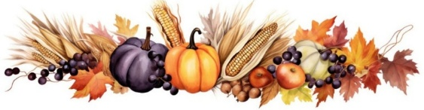
Student Fall Retreats

https://ncbaptist.org/ministries/student/student-resources/

Oct. 23-25, 2026, Ridgecrest Conference Center

Cooperative Program Day
Sunday, October 4th

The Cooperative Program: The financial fuel for reaching every person for Jesus Christ in every town, every city, every state, and every nation.

Many of our churches could never afford to send and support a missionary overseas or one serving the inner city of one of our great cities. Many of our churches couldn’t start a seminary or know how to stand against the wickedness and false teaching of this world. But by combining our financial resources, we can do great things for the glory of God! Together through the Cooperative Program, we are funding North Carolina Missions, North American Missions and even International Missions!

Imagine Anson Baptist Church gives 10% of its undesignated receipts ($100,000) to the Cooperative Program. In a years’ time they will have given $10,000 to Missions! In NC, 50% ($5,000) would go to the national Southern Baptist Convention where it is used for National and International missions. The other 50% stays in NC and is used for NC missions, evangelism and church planting. See the breakdown below.

2026 NC Baptists Cooperative Missions Budget

* Institutions and Agencies – 11.98% = $3,595,000
* Christian Social Services – 8% = $2,400,000
* Agencies – 0.83% = $250,000
* Fruitland Baptist Bible College – 2.33% = $700,000
* GuideStone & Church Protection Benefits – 0.82% =
$245,000
* North Carolina Ministries – 38.02% = $11,405,000
* Convention Ministry Groups – 30.10% = $9,030,000
* Convention & Board Operations – 7.92% =
$2,375,000

Global Missions (SBC) – 50% = $15,000,000
Total 2026 CP Budget – 100% = $30,000,000

Cooperative Program Links:

https://www.sbc.net/missions/the-cooperative-program/

https://ncbaptist.org/about/cooperative-program/

https://ncbaptist.org/about/budget/

https://www.sbc.net/resource-library/52-sundays/

SBC National
Cooperative Program Budget

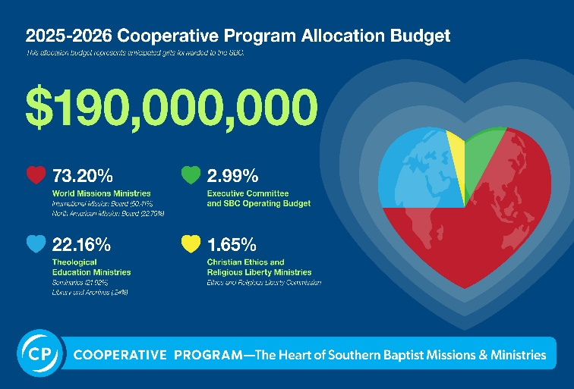

Who Loves Ya Baby?

A sucker chomping TV detective popularized the question, but I am reminded of your pastor who loves you and is often there for you during some of the most difficult and painful times of your life. Your pastor loves you enough to teach you the truth of God’s Word even when it is not popular. Your pastor loves you and prays for you, so take advantage of Pastor Appreciation month to show your pastor some brotherly or sisterly love. Give him a card sharing how he has blessed you or encouraged you. Give him a gift certificate or a favorite desert. Invite him and his family over for dinner! However you do it, let you pastor know that you love him in the Lord too!

October is….

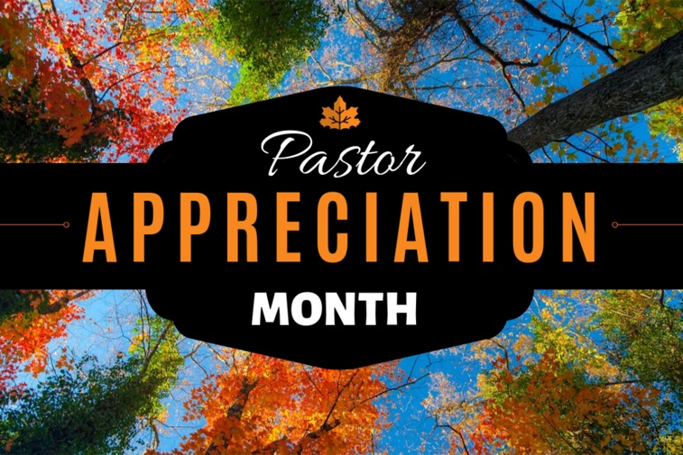
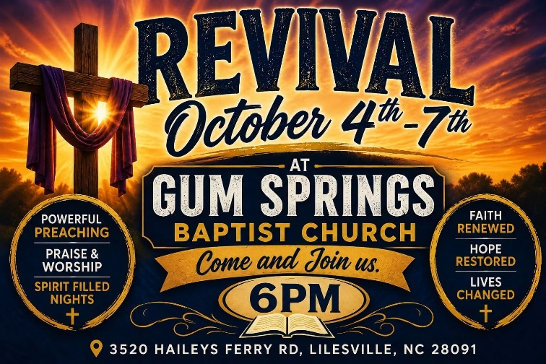

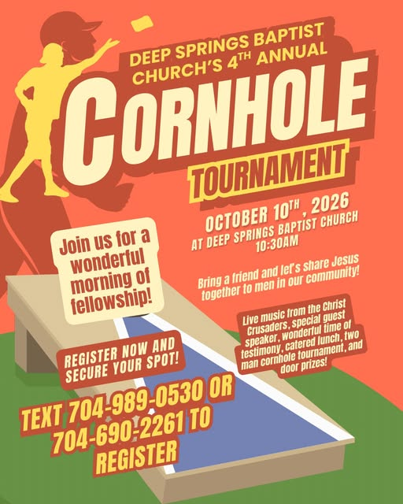



The Anson Crisis Ministry need for October is grits or oatmeal. ACM needs volunteers to serve, and monetary donations are appreciated as well. Hours are Tuesday-Friday, 8 am until 1 pm. Margot Barnes is director and can be reached at 704-694-2445. You can access more information at: www.ansoncrisisministry.com.


Real People. Real Choices. Real Consequences.

October 21-25, 2026


Beverly Hills
Baptist Church
110 Kemberly St, Rockingham, NC 28379, Phone: 910-895-9862

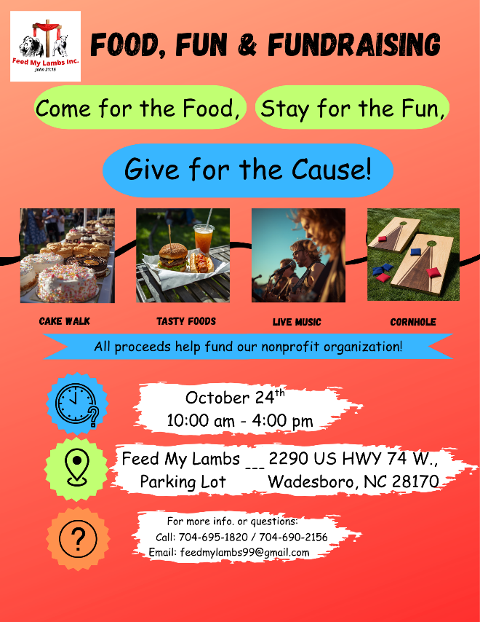

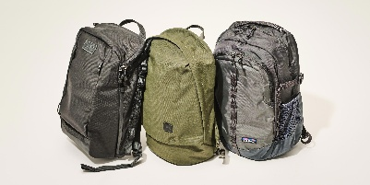
Blessing
Bags

The ABA Mission Team needs churches to pack backpacks (Blessing Bags) for the month of December. Ten are needed for each month. There are some backpacks and Bibles at the ABA available at cost. If you would be able to help with this ministry, please contact Beth Rogers at 704-695-2010. We give a big THANK YOU to those churches who have participated in this ministry to those in need!


We are seeking to partner with Child Evangelism Fellowship in forming Christian clubs in our elementary schools. We already have Christian clubs in our high school and early college, but there aren’t any for our children in our elementary schools. This is a great opportunity to share the love of God with children in our county! We are looking for mission minded churches and volunteers who love children that would like to be a part of this new and exciting ministry. If you and/or your church would be interested, please contact David at the ABA for more information. Email: revdwr76@gmail.com Or cell: (252) 396-1368.




Thank you to the following churches for their September financial support: Calvary, Deep Creek, Freedom, Lilesville, Morven, Mt. Beulah, New Home, Peachland, Red Hill, & Victory


Refuge
Of Grace

“God is our refuge and strength,
A very present help in trouble.” (Psalm 46:1)

Thursday Nights at 6:30 PM
North Wadesboro Baptist Church
1211 N. Greene St., Wadesboro, NC 28170

Refuge Of Grace is a Christ centered recovery program to help people “find freedom from their hurts, hang-ups, and habits” including addiction. For more information contact David Wesley Helms at (980) 278-6189 or Rev. Ernie Walters at (910) 506-6066.
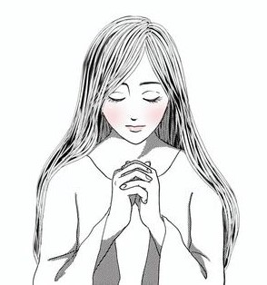
WMU World
Day of Prayer
November 2, 2024
at 6:00 PM

Anson Baptist Association

Pastor & Wives Banquet

November 7th from 5:30 - 7:00 PM


Join us for a great time of food, fellowship and door prizes! Pastors are encouraged to bring a spouse or a friend, but are always welcome singly too. Please register by November 2nd, so we can be sure to have enough food for everyone. Thanks!

International Day of Prayer
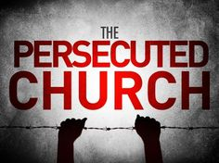

Sunday, November 1st

“The International Day of Prayer for Persecuted Christians (IDOP), observed each year on the first Sunday in November, is an opportunity for the global body of Christ to unite in prayer for our persecuted Christian family members. For more information and digital promotion resources go to: https://www.persecution.com/idop/

“HIS WORKMANSHIP” - Ephesians 2:10
Men’s Worship Rally
Thursday, November 12, 2026
New Home Baptist Church
Sponsored by Baptists on Mission
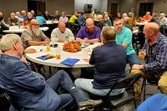

All men are invited to an evening of fellowship that will include supper followed by a time of worship, testimony, a spiritual challenge, and prayer. We'll highlight mission opportunities as well as some men's ministry resources that can be used in the local church. Join others from the region as we pursue being the men God created us to be! Meal begins at 6:15 pm. Program is from 7:00-8:30 pm. Cost is $5 per man, and helps cover the cost of the meal.
Every man and his pastor is encouraged to attend! Registration is required for accurate meal count. Register online at www.baptistsonmission.org/mwr - or - call Tina Holder at the Baptist on Mission Office at 919-459-5596. We hope to see you and your men there!


2026 Appalachian
Christmas Outreach
Backpack Ministry

The Appalachian Christmas Outreach Backpack Ministry serves many poor and needy children in the Appalachian Mountains region. Bless a child for Jesus by filling up a backpack! Go to https://baptistsonmission.org/Appalachian-Christmas-Outreach to learn more about this ministry and what to put in each backpack.

You can drop off your backpacks at the Anson Baptist Association Mission Center during our regular office hours, 9:00 AM – 2:00 PM (But David is usually there till 5 PM) Monday – Thursdays through Nov. 4th; or you can drop off your backpacks at New Home Baptist Church, 1617 New Home Church Road, Peachland, NC, on Saturday, November 7th, by making an appointment with Polly Alexander, at Tom.polly.alexander@gmail.com, Phone: (704) 475-1390, or David Ross at the ABA at revdwr76@gmail.com, office phone, (704) 694-2790.


Vote November 3rd!!

Early voting begins October 15 and ends October 31, 2026. Polls are open from 6:30 a.m. until 7:30 p.m. on Election Day.

Every Christian needs to vote because “elections have consequences.” Our votes affect more than our pocket books. It effects many moral issues in our country. Local elections affect our daily lives and schools. Voting is more than our civic responsibility; it is a religious one too. Do your homework. Research the candidates.

Elections are more than about personalities, they are about policies. Politicians are known for not always telling the truth about what they believe and what they will do, so how can we know what they will do if elected?
1. What have they done in the past?
2. What is the platform of their party. 9.5 times out of 10, a politician will vote according to their party platform.
https://ivoterguide.com/
https://www.myfaithvotes.org/myvoterhub/state/NC

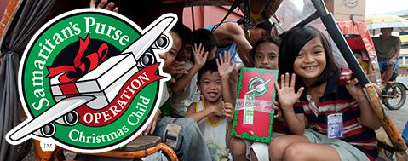
This Photo by Unknown Author is licensed under CC BY-SA-NC

Operation Christmas Child
National Collection Week, Nov. 16–23, 2026
Mt. Beulah Baptist Church is a collection site.

Samaritan’s Purse sends gift-filled Operation Christmas Child shoeboxes to children in need around the world together with the message of the Gospel of Jesus Christ.

For more information go to: https://www.samaritanspurse.org/what-we-do/operation-christmas-child

NC BAPTIST ANNUAL MEETING
To register or for more information go to: https://ncbaptist.org/annual-meeting/

